**2017**

Install R: R Studio and Cleaning data

MSDS680 – Assignment 1, Sep 03, 2017

Regis University – MSDS Program

Abstract

Practice data cleaning/ pre-processing (e.g. check the missing records, remove the missing records, impute with mean/ median, convert and attribute to dummy variables, scaling, normalization, etc.) with the data of your choice.  
State the objective of each command, display the command, and their corresponding results. Use at least 7 different commands.

Rajkumar Shanmuganathan

Table of Contents

Introduction 3

PART I: Installation 3

Install R 3

Install R Studio 4

PART II: Data cleaning/ data pre-processing 5

Importance of Data cleaning 5

Data Cleaning/ Pre-processing 6

Techniques 7

Packages in R for Data Cleaning & Visualization (Machlis, 2017) 8

Part III – PRACTICE 9

Titanic: Machine Learning from Disaster (Kaggle, 2012) 9

Data Load 10

Missing Values 10

Imputation 11

Dummy Variables 12

Correlated attributes 12

Scaling & Normalization 12

Conclusion 13

Works Cited 14

Table of Figures

Figure 1: R Shell window 3

Figure 2: R Studio window 4

Figure 3: Shows how systema-tic corruption of data (from circles to crosses) can lead to a shifted, incorrect model. (Krishnan & Wu, n.d.) 5

Figure 4: Illustrates the true model if the full dataset were cleaned. (Krishnan & Wu, n.d.) 5

# Introduction

This paper is in response to the assignment 1 for MSDS680, and it presents common techniques involving the installation of R, R Studio soft wares and It evaluates key methodologies involving the data cleaning/ data pre-processing with the practical application of them using R commands with the illustration of their outcomes.

# PART I: Installation

Install R

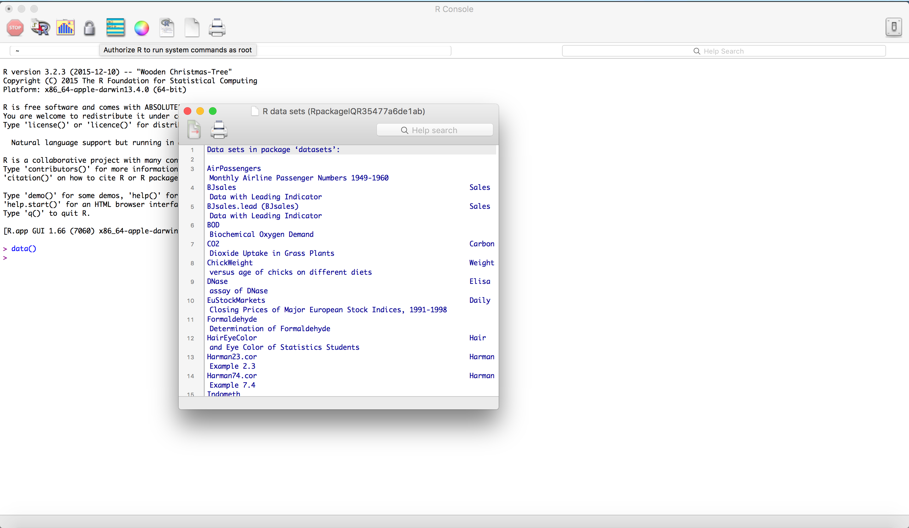R is a free software environment for statistical computing and graphics. It compiles and runs on a wide variety of Unix platforms, windows and macOS. R can be downloaded & installed from the below mirror sites. (R-Project, n.d.).

Figure 1: R Shell window

<https://cran.r-project.org/mirrors.html>

<https://cran.cnr.berkeley.edu/bin/macosx/>

Please find the R Shell window on the right side above. You can get the version information with the below command.

> version

platform x86_64-apple-darwin15.6.0

arch x86_64

os darwin15.6.0

system x86_64, darwin15.6.0

status

major 3

minor 4.1

year 2017

month 06

day 30

svn rev 72865

language R

version.string R version 3.4.1 (2017-06-30)

nickname Single Candle

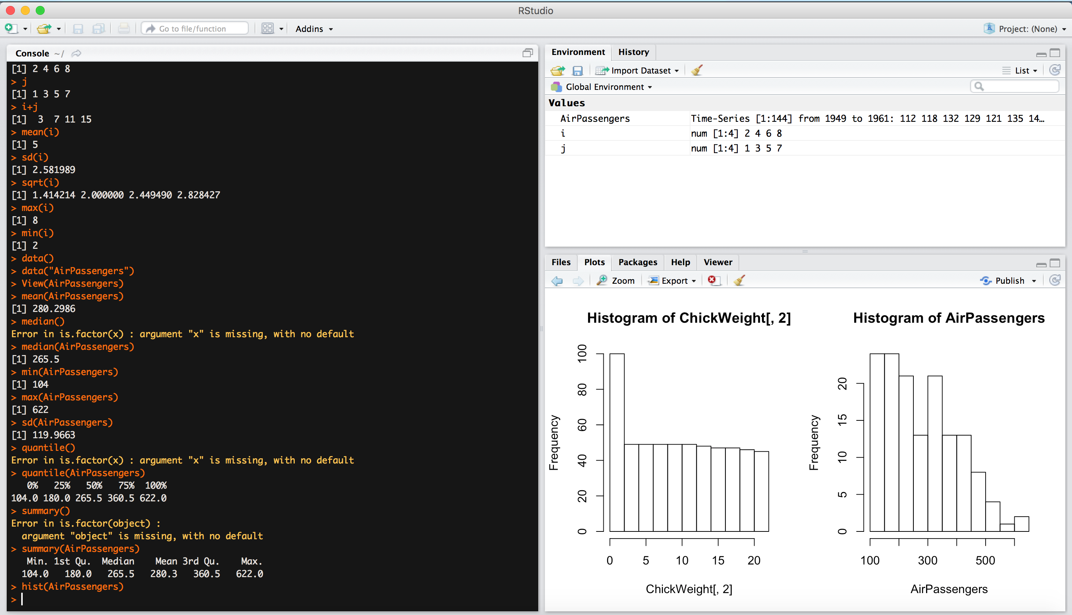Install R Studio

Figure 2: R Studio window

R Studio is an integrated development environment (IDE) for R. It includes a console, syntax-highlighting editor that supports direct code execution, as well as tools for plotting, history, debugging and workplace management. RStudio is available in open source and commercial editions and runs on the desktop (Windows, Mac, and Linux) or in a browser connected to RStudio Server or RStudio Server Pro (Debian/Ubuntu, RedHat/CentOS, and SUSE Linux). (R Studio, n.d.)

R Studio can be downloaded using the below URLs.

<https://www.rstudio.com/products/rstudio/download/#download>

<https://download1.rstudio.org/RStudio-1.0.153.dmg>

The below command will reveal the R Studio version in R Studio Session.

> RStudio.Version()

$citation

To cite RStudio in publications use:

RStudio Team (2016). RStudio: Integrated Development for R. RStudio, Inc., Boston, MA URL http://www.rstudio.com/.

A BibTeX entry for LaTeX users is

@Manual{,

title = {RStudio: Integrated Development Environment for R},

author = {{RStudio Team}},

organization = {RStudio, Inc.},

address = {Boston, MA},

year = {2016},

url = {http://www.rstudio.com/},

}

$mode

[1] "desktop"

$version

[1] ‘1.0.143’

# PART II: Data cleaning/ data pre-processing

Importance of Data cleaning

Databases can be corrupted with various errors such as missing, incorrect, or inconsistent values. Increasingly, modern data analysis pipelines involve Machine Learning, and the effects of dirty data can be difficult to debug. Dirty data is often sparse, and naive sampling solutions are not suited for high-dimensional models. The following figures show how data cleaning can degrade the machine learning model. (Krishnan & Wu, n.d.)

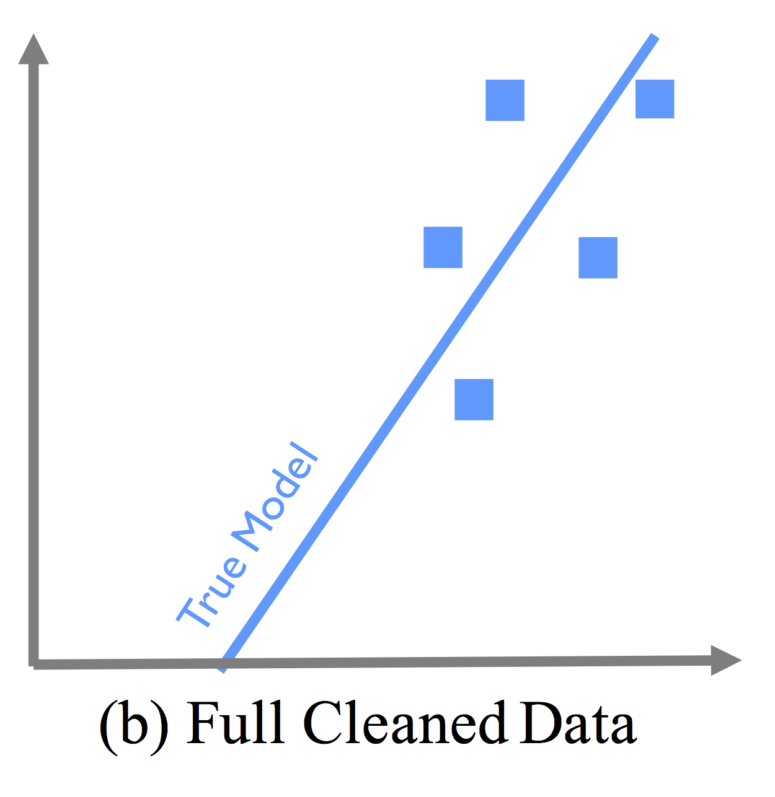

Figure 3: Shows how systema-tic corruption of data (from circles to crosses) can lead to a shifted, incorrect model. (Krishnan & Wu, n.d.)

Figure 4: Illustrates the true model if the full dataset were cleaned. (Krishnan & Wu, n.d.)

According to New York Times article, Data scientists are spending 50% to 80% of their time in the labor-intensive data collection, preparing unruly digital data, before it can be exploded into useful nuggets. (LOHR, 2014)

“*It’s an absolute myth that you can send an algorithm over raw data and have insights pop up*,” said Jeffrey Heer, a professor of computer science at the University of Washington and a co-founder of Trifacta, a start-up based in San Francisco. (Evans, n.d.)

“*Cleaning up data to the point where you can work with it is a huge amount of work. If you’re trying to reconcile a lot of sources of data that you don’t control like in this flight search example, it can take 80% of your time.”,* said Julia Evans. (Evans, n.d.)

R provides various packages, libraries that supports data cleanings & preparations such as data wrangling, data pre-processing and etc. The following are few packages; *deplyr, tidyr, caret, Applied Predictive Modeling and etc.*

Data Cleaning/ Pre-processing

“Data cleaning, or data preparation is an essential part of statistical analysis. In fact, in practice it is often more time-consuming than the statistical analysis itself”, said Edwin de Jonges and Mark van der Loo. (Jong & Loo, 2013)

Data cleaning can mean a lot of things, but generally it can be categorized into the below subjects or group of these subjects.

1. Technically correct data
   1. It can be directly recognized as belonging to a certain variable;(Jong & Loo, 2013)
   2. It is stored in a data type that represents the value domain of the real-world variable(Jong & Loo, 2013).
2. Character manipulation
   1. Because of the many ways people can write the same things down, character data can be difficult to process. For example, consider the following excerpt of a data set with a gender variable.(Jong & Loo, 2013)
3. Character encoding issues
   1. A character encoding system is a system that defines how to translate each character of a given alphabet into a computer byte or sequence of bytes.(Jong & Loo, 2013)
4. Consistent Data
   1. Consistent data are technically correct data that are fit for statistical analysis. They are data in which missing values, special values, (obvious) errors and outliers are either removed, corrected or imputed.(Jong & Loo, 2013)
5. Imputation
   1. Imputation is the process of estimating or deriving values for fields where data is missing.(Jong & Loo, 2013)
6. Correction
   1. Correction methods aim to fix inconsistent observations by altering invalid values in a record based on information from valid values. Depending on the method this is either a single-step procedure or a two-step procedure where first, an error localization method is used to empty certain fields, followed by an imputation step.(Jong & Loo, 2013)

Techniques

1. Dummy variables
   1. The dummy variables can be generated from one or more factors, it is generally used to simplify the complex factors or data.frame for better readability.
   2. The function dummyVars can be used to generate a complete (less than full rank parameterized) set of dummy variables from one or more factors. The function takes a formula and a data set and outputs an object that can be used to create the dummy variables using the predict method. (Kuhn, 2017)
2. Zero and Near Zero-variance Predictors
   1. In some situations, the data generating mechanism can create predictors that only have a single unique value (i.e. a “zero-variance predictor”). For many models (excluding tree-based models), this may cause the model to crash or the fit to be unstable. (Kuhn, 2017)
   2. There are 2 types of metrics can be calculated for these types of predictors; Frequency Ratio & Percent of Unique values.
   3. the nearZeroVar function can be used to identify near zero-variance variables (the SaveMetrics argument can be used to show the details and usually defaults to FALSE )
3. Identifying correlated Predictors
   1. While there are some models that thrive on correlated predictors (such as pls), other models may benefit from reducing the level of correlation between the predictors. (Kuhn, 2017)
   2. The findCorrelation function uses the following algorithm to flag predictors for removal.
4. Linear Dependencies
   1. Similar to correlation, linear dependency predictors also need to be removed as some of the models may benefit from reducing the dependent predictors. Two variables are linearly dependent if one can be written as a linear function of the other. (Chernick, 2012)
   2. The function findLinearCombos uses the QR decomposition of a matrix to enumerate sets of linear combinations (if they exist) (Kuhn, 2017).
5. Preprocess function (Imputation, Centering & Scaling)
   1. The preProcess class can be used for many operations on predictors, including centering and scaling. The function preProcess estimates the required parameters for each operation and predict.preProcess is used to apply them to specific data sets. This function can also be interfaces when calling the train function. (Kuhn, 2017)
6. Transformation
   1. In some cases, there is a need to use principal component analysis (PCA) to transform the data to a smaller sub–space where the new variable are uncorrelated with one another. The preProcess class can apply this transformation by including "pca" in the method argument. Doing this will also force scaling of the predictors (Kuhn, 2017).
   2. The “spatial sign” transformation (Serneels, Nolf, & Espen, 2006) projects the data for a predictor to the unit circle in p dimensions, where p is the number of predictors. Essentially, a vector of data is divided by its norm. (Kuhn, 2017)
7. Class distance Calculations
   1. caret contains functions to generate new predictors variables based on distances to class centroids (similar to how linear discriminant analysis works). For each level of a factor variable, the class centroid and covariance matrix is calculated. For new samples, the Mahalanobis distance to each of the class centroids is computed and can be used as an additional predictor. This can be helpful for non-linear models when the true decision boundary is actually linear. (Kuhn, 2017)
   2. predict.classDist is then used to generate the class distances. By default, the distances are logged, but this can be changed via the trans argument to predict.classDist. (Kuhn, 2017)
8. Data Wrangling
   1. It is generally a set of operations from library like tidyr, dplyr that helps to configure each variable in its own column, each observation to save in its own row and each type of observation to store in a single table. (Grolemund, 2015)
   2. The functions like unite, separate, gather and spread will help arrange the data in a more technically corrected data.
   3. The functions like select, filter, mutate and summarise will help you run SQL like functions on the data.frame to help run data manipulation operations.
   4. The function arrange will order the data by specific column and group_by function will help the data.frame group by given column(s).
   5. There are lot of functions such as bind_cols, bind_rows, union, intersect, setdiff, left_join, inner_join, semi_join and anti_join are used to join data from different data.frames.

Packages in R for Data Cleaning & Visualization (Machlis, 2017)

|  |  |  |  |
| --- | --- | --- | --- |
| PACKAGE | CATEGORY | DESCRIPTION | AUTHOR |
| devtools | package development, package installation | While devtools is aimed at helping you create your own R packages, it's also essential if you want to easily install other packages from GitHub. Install it! Requires Rtools on Windows and XCode on a Mac. On CRAN. | Hadley Wickham & others |
| readr | data import | Base R handles most of these functions; but if you have huge files, this is a speedy and standardized way to read tabular files such as CSVs into R data frames, as well as plain text files into character strings with read_file. CRAN. | Hadley Wickham |
| XML | data import, data visualization, data analysis | Many functions for elegantly dealing with XML and HTML, such as readHTMLTable. CRAN. | Jeffrey A. Ryan |
| dplyr | data wrangling, data analysis | The essential data-munging R package when working with data frames. Especially useful for operating on data by categories. CRAN. | Hadley Wickham |
| reshape2 | data wrangling | Change data row and column formats from "wide" to "long"; turn variables into column names or column names into variables and more. The tidyr package is a newer, more focused option, but I still use reshape2. CRAN. | Hadley Wickham |
| tidyr | data wrangling | While I still prefer reshape2 for general re-arranging, tidy won me over with specialized functions like fill (fill in missing columns from data above) and replace_na. CRAN. | Hadley Wickham |
| caret | Classification and Regression Training | It contains lot of preprocessing functions. | Max Kuhn |

# Part III – PRACTICE

Titanic: Machine Learning from Disaster (Kaggle, 2012)

I have taken Titanic data set from Kaggle (tutorial) to practice the data cleaning/ pre-processing techniques. There are 2 data sets available; 1. Train, 2. Test.

Data Dictionary (Kaggle, 2012)

|  |  |  |
| --- | --- | --- |
| VARIABLE | DEFINITION | KEY |
| survival | Survival | 0 = No, 1 = Yes |
| pclass | Passenger Ticket Class | 1 = 1st, 2 = 2nd, 3 = 3rd |
| sex | Sex |  |
| age | Age in years |  |
| sibsp | # of Siblings/ spouses aboard the Titanic |  |
| parch | # of parents/ children aboard the Titanic |  |
| ticket | Ticket Number |  |
| fare | Passenger Fare |  |
| cabin | Cabin Number |  |
| embarked | Port of Embarkation | C = Cherbourg, Q = Queenstown, S = Southampton |

Data Load

> titanic_kaggle <- read.csv('train.csv')

> View(titanic_kaggle)

> tbl_df(titanic_kaggle) #for better readability.

> dim(titanic_kaggle) #dimension of the data.

[1] 891 12

Missing Values

> titanic_kaggle %>% is.na() %>% sum()

[1] 177

> titanic_kaggle$Age %>% is.na() %>% sum()

[1] 177

> filter(titanic_kaggle,is.na(Age)) %>% tbl_df

#.. too big result to show here ..

> sum(titanic_kaggle$Embarked=="")

[1] 2

> sum(titanic_kaggle$Cabin=="")

[1] 687

This data set has 177 missing values for Age column. Which is close to 20% of the data. The missing values can be easily removed using na.omit() command, but doing so, will result in huge data loss for this data set. Maybe we can try and fix the missing value by estimating (or imputating) it. (Robert I. Kabacoff, 2017)

Imputation

Since the Age column has missing values, we can try imputate that variable with the Simple Mean & median. (akrun, 2014)

> titanic_kaggle <- transform(titanic_kaggle,Age = ifelse(is.na(Age), median(Age,na.rm = TRUE),Age))

> titanic_kaggle$Age %>% is.na() %>% sum()

[1] 0

> titanic_kaggle$Embarked[titanic_kaggle$Embarked==""] <- NA

> titanic_kaggle <- na.omit(titanic_kaggle)

> titanic_kaggle$Embarked[titanic_kaggle$Embarked==""]

factor(0)

Levels: C Q S

> library(stringr)

> titanic_kaggle$CabinGrp <- substring(titanic_kaggle$Cabin,0,1)

> titanic_kaggle %>% group_by(CabinGrp,Embarked) %>% summarise(Mean=mean(Fare), Median = median(Fare)) # find the mean & median value based on the cabin group & embarkation location. It will help us estimation & imputate the missing values for Cabin.

# A tibble: 20 x 4

# Groups: CabinGrp [?]

CabinGrp Embarked Mean Median

<chr> <fctr> <dbl> <dbl>

1 C 30.98334 14.45420

2 Q 11.26239 7.75000

3 S 18.00306 10.50000

4 A C 38.35774 35.50000

5 A S 40.73176 42.75000

6 B C 145.96402 79.20000

7 B S 85.37228 86.50000

8 C C 98.58253 89.10420

9 C Q 90.00000 90.00000

10 C S 101.63044 72.72500

11 D C 74.47021 76.72920

12 D S 46.04791 45.63125

13 E C 92.90584 83.15830

14 E Q 12.35000 12.35000

15 E S 38.30673 26.55000

16 F C 22.35830 22.35830

17 F Q 7.75000 7.75000

18 F S 19.35909 13.00000

19 G S 13.58125 13.58125

20 T S 35.50000 35.50000

# Based on the above observation, the Cabin value can be imputated using the above command used for Age.

Dummy Variables

> titanic_kaggle_df$Ticket <- NULL

> titanic_kaggle_df$Name <- NULL

> titanic_kaggle_df$Cabin <- NULL

> titanic_kaggle_df_dv <- model.matrix(Survived ~ ., data = titanic_kaggle_df)

> head(titanic_kaggle_df_dv)

(Intercept) PassengerId Pclass Sexmale Age SibSp Parch Fare EmbarkedC EmbarkedQ EmbarkedS CabinGrpA CabinGrpB CabinGrpC CabinGrpD CabinGrpE CabinGrpF CabinGrpG CabinGrpT

1 1 1 3 1 22 1 0 7.2500 0 0 1 0 0 0 0 0 0 0 0

2 1 2 1 0 38 1 0 71.2833 1 0 0 0 0 1 0 0 0 0 0

3 1 3 3 0 26 0 0 7.9250 0 0 1 0 0 0 0 0 0 0 0

4 1 4 1 0 35 1 0 53.1000 0 0 1 0 0 1 0 0 0 0 0

5 1 5 3 1 35 0 0 8.0500 0 0 1 0 0 0 0 0 0 0 0

6 1 6 3 1 28 0 0 8.4583 0 1 0 0 0 0 0 0 0 0 0

The columns such as Ticket, Name & Cabin are removed due to the fact that they are unique identifier so the passenger. The above command creates various dummy variables to normalize the data.

Correlated attributes

> titanic_kaggle_df$Ticket <- NULL

> titanic_corr <- cor(titanic_kaggle_df_dv[,-1])

> highlyCor_titanic <- findCorrelation(titanic_corr, cutoff = .75)

> titanic_kaggle_df_dv[,-highlyCor_titanic]

# the above command removes the column EmbarkedQ due to fact that it has more than .75 correlation with other attributes.

Scaling & Normalization

> titanic_scaled <- scale(titanic_kaggle_df_dv[,-1],center = TRUE,scale = TRUE)

> tbl_df(titanic_scaled)

# A tibble: 889 x 18

PassengerId Pclass Sexmale Age SibSp Parch

<dbl> <dbl> <dbl> <dbl> <dbl> <dbl>

1 -1.731530 0.8247444 0.7349283 -0.5633570 0.4311076 -0.4740590

2 -1.727639 -1.5713267 -1.3591463 0.6688405 0.4311076 -0.4740590

3 -1.723748 0.8247444 -1.3591463 -0.2553076 -0.4749317 -0.4740590

4 -1.719857 -1.5713267 -1.3591463 0.4378034 0.4311076 -0.4740590

5 -1.715966 0.8247444 0.7349283 0.4378034 -0.4749317 -0.4740590

6 -1.712074 0.8247444 0.7349283 -0.1012829 -0.4749317 -0.4740590

7 -1.708183 -1.5713267 0.7349283 1.9010379 -0.4749317 -0.4740590

8 -1.704292 0.8247444 0.7349283 -2.1036037 2.2431862 0.7654659

9 -1.700401 0.8247444 -1.3591463 -0.1782953 -0.4749317 2.0049907

10 -1.696510 -0.3732912 -1.3591463 -1.1794557 0.4311076 -0.4740590

# ... with 879 more rows, and 12 more variables: Fare <dbl>, EmbarkedC <dbl>,

# EmbarkedQ <dbl>, EmbarkedS <dbl>, CabinGrpA <dbl>, CabinGrpB <dbl>,

# CabinGrpC <dbl>, CabinGrpD <dbl>, CabinGrpE <dbl>, CabinGrpF <dbl>,

# CabinGrpG <dbl>, CabinGrpT <dbl>

# Conclusion

In response to the assignment 1 – MSDS680, the below objectives are satisfied,

1. Install R & R Studio.
2. Learn data cleaning & data pre-processing in Data science
3. Learn different data cleaning & normalization techniques.
4. Practice data cleaning with choice of data with the student’s own liking and demonstrate it with at least 7 commands.

# Works Cited

akrun. (2014, 08 14). *how to calculate mean/median per group in a dataframe in r [duplicate]* . Retrieved from https://stackoverflow.com: https://stackoverflow.com/questions/25198442/how-to-calculate-mean-median-per-group-in-a-dataframe-in-r

Chernick, M. (2012, 06 28). *What is the difference between linearly dependent and linearly correlated?* Retrieved from https://stats.stackexchange.com/: https://stats.stackexchange.com/questions/31270/what-is-the-difference-between-linearly-dependent-and-linearly-correlated

Evans, J. (n.d.). *Machine learning isn't Kaggle competitions*. Retrieved from https://jvns.ca/: https://jvns.ca/blog/2014/06/19/machine-learning-isnt-kaggle-competitions/

Grolemund, G. (2015, 01). *Data-Wrangling-with-R-and-RStudio.* Retrieved from Github.com: https://github.com/rstudio/webinars/blob/master/05-Data-Wrangling-with-R-and-RStudio/wrangling-webinar.pdf

Jong, E. d., & Loo, M. v. (2013). *Introduction to Data Cleaning with R* (13 ed.). Henri Faasdreef, Netherlands: Statistics Netherlands.

Kaggle. (2012). *Titanic: Machine Learning from Disaster*. Retrieved from https://www.kaggle.com/: https://www.kaggle.com/c/titanic/data

Krishnan, S., & Wu, E. (n.d.). *Cleaning for Data Science*. Retrieved from https://activeclean.github.io/: https://activeclean.github.io/

Kuhn, M. (2017, 07 23). *3 Pre-Processing*. Retrieved from http://topepo.github.io: http://topepo.github.io/caret/pre-processing.html

LOHR, S. (2014, 08 17). *For Big-Data Scientists, ‘Janitor Work’ Is Key Hurdle to Insights.* Retrieved from https://www.nytimes.com: https://www.nytimes.com/2014/08/18/technology/for-big-data-scientists-hurdle-to-insights-is-janitor-work.html

Machlis, S. (2017, 06 23). *Great R packages for data import, wrangling and visualization*. (Computerworld) Retrieved from https://www.computerworld.com: https://www.computerworld.com/article/2921176/business-intelligence/great-r-packages-for-data-import-wrangling-visualization.html

R Studio. (n.d.). *Take control of your R code*. Retrieved from https://www.rstudio.com/products/RStudio/: https://www.rstudio.com/products/RStudio/

Robert I. Kabacoff, P. (2017). *Missing Data*. Retrieved from http://www.statmethods.net: http://www.statmethods.net/input/missingdata.html

R-Project. (n.d.). *The R Project for Statistical Computing*. Retrieved from https://www.r-project.org/: https://www.r-project.org/

Serneels, S., Nolf, E. D., & Espen, P. J. (2006, 02 23). Spatial Sign Preprocessing:  A Simple Way To Impart Moderate Robustness to Multivariate Estimators. *Journal of Chemical Information and Modeling*. Retrieved from http://pubs.acs.org/: http://pubs.acs.org/doi/abs/10.1021/ci050498u